# [‘SVU’ showrunners on what’s to come (romance?!) for Olivia Benson and her squad in Season 24](https://www.today.com/popculture/tv/law-order-svu-showrunners-talk-olivia-benson-elliot-stabler-rcna43579)

Who better to turn to for what's in store in Season 24 than showrunner David Graziano and head writer and executive producer Julie Martin?

Sept. 7, 2022, 1:28 PM -03 / Source: TODAY

By MC Suhocki

The [“Law & Order” franchise returns](https://www.today.com/popculture/tv/mariska-hargitay-posts-new-pic-chris-meloni-law-order-set-rcna39869) in less than one month on Sept. 22 with [a huge premiere even](https://www.today.com/popculture/tv/law-order-brings-3-casts-together-first-time-historic-crossover-rcna44435)t in which all three "L&O" shows will cross over with one another, and we’ve still got lingering questions from the “SVU” Season 23 finale, especially relating to the personal bombs dropped on lead [Olivia Benson (Mariska Hargitay](https://www.today.com/popculture/tv/olivia-benson-elliot-stabler-relationship-timeline-law-and-order-svu-rcna37289)). Who better to ask than the show’s fearless leaders: veteran executive producer and head writer Julie Martin and newcomer and self-proclaimed fan and showrunner David Graziano.

Season 23 ended with Benson confiding in her therapist that she hasn’t been happy for a year, and her therapist encouraged her to explore a romance with [her former partner Elliot Stabler (Chris Meloni)](https://www.today.com/popculture/tv/elliot-stablers-back-nearly-year-happening-benson-rcna19588), who unexpectedly [returned to her life](https://www.today.com/popculture/stabler-s-coming-home-new-law-order-spinoff-teaser-completely-t209518) after a 10-year absence, or to move on from this “idealized relationship.” Benson’s friend Detective Amanda Rollins (Kelli Giddish), who’s been involved in a romance of her own with her former partner and current ADA, Dominick Carisi (Peter Scanavino), separately suggested to Benson that she and Stabler could go to a hotel room to get [whatever has built up between them after all these years](https://www.today.com/popculture/tv/law-order-star-chris-meloni-talks-stablers-feelings-benson-rcna16658), and more recently [since his return](https://www.today.com/popculture/benson-stabler-got-personal-law-order-christmas-crossover-t242774), out of their systems. On Aug. 24, after this interview was conducted, [Giddish announced](https://www.today.com/popculture/tv/svu-veteran-kelli-giddish-12-seasons-show-rcna44676) the upcoming season of “SVU” will be her last after 12 years with the show.

Below, Martin and Graziano weigh in on what’s to come for Benson and her squad, both [personal](https://www.today.com/popculture/tv/olivia-benson-perfect-response-son-coming-svu-rcna12247) and professional, in Season 24.

## David, you’ve clearly been a fan of this show for a long time and once even sent a script to (former 'SVU' showrunner) Neal Baer. I’m just curious if you remember what the plot was of the script you sent him, and also why has this show meant so much to you for so long?

**DG:** I don't remember what the plot is actually. I wrote it when I was in NYU, and I'm sure it was horrible. I just sent it off. I pretended to be like Michael Madsen, and I called the production office just to get the address of the production office and I sent it off. Never heard back from him but Neal and I had worked together (on a pilot) a couple years ago, and we became close. I told him that story. He was, like, laughing.

But I connected with the show early on. I really liked some of Julie (Martin)'s work on "Homicide" ("Life on the Street"). I was a huge fan of "Homicide." I've always been a fan of crime shows. I saw a murder happen in front of me when I was a teenager, and it got me obsessed with why people do the things they do — particularly with respect to criminality and human nature, the dark parts of human nature. And it kind of turned me into a crime writer. And so, I've always been obsessed with well-wrought cop shows, and the voices and the patter of them is really fun. And I saw it as a genre where you can actually say something real. "SVU," in particular, struck a chord with me because it's about trauma, and the psychology behind these episodes is really fascinating and picking apart the psychology of the perpetrators and then looking at the victim psychology, too. It added a therapeutic, psychological layer to the show that I didn't see on other cop shows, and I found that really, particularly, fascinating. Once you think about unmasking somebody, like shining a light on these things that are kind of usually done in the darkness, it's very cathartic.

## Julie, I know you’ve been with 'SVU' for about 10 years now. I’m wondering how you think this season, now that David’s on board as well, will differ, especially for the characters, from the previous seasons you’ve worked on?

**JM:** Well, I think after a show's been on the air for 24 years, and I've been on it for 10 years, we're always looking to keep the show fresh, keep the show relevant, to keep the characters changing and growing. They're basically who they are — we're not going to 180 these characters but try to find different facets of their personalities and their investigative abilities and just where they are in their lives that we haven't seen before.

And I think it's a wonderful opportunity for a new showrunner to come in with a fresh take on the squad and fresh ideas about how these characters should interact. And so far, it's been working great.

## David, I know you’ve said you’re a big fan of the early years of 'SVU.' Is there an episode that stands out to you from that time as your favorite?

**DG:** I was blown away by anything that (Detective John) Munch (Richard Belzer) was in. He represents all the ideals I have as a writer, like in terms of writing that crisp dialogue and the patter. And I really like the energy between them. And I loved all of the episodes with Stabler and Benson — again, because of the patter. They're playing off each other in that lovely kind of way. There's great shows in TV history like "The X-Files," "Moonlighting": There's a musicality to a partnership.

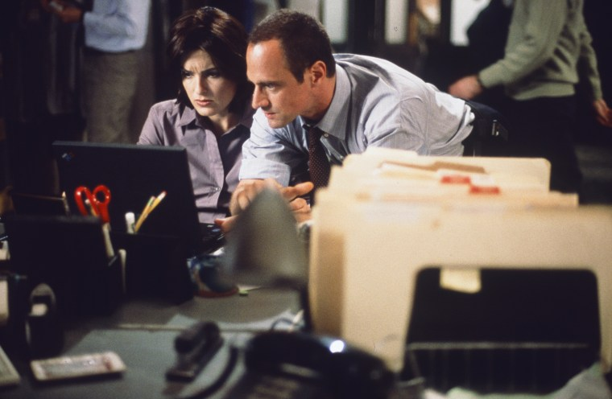Benson and Stabler in a Season One episode of "SVU" in 1999.Jessica Burstein / NBCUniversal via Getty Images

I like to think Julie and I have developed a similar musicality in working. We've been chained to each other every day just going over these episodes and bringing them together and doing the dialogue of the show. It's really fun to do, but I'm obsessed with patter between partners. So I really love those early years. The cadence of it and the pace of it and the internal pulse of it is really what draws me into this style of writing, and I'm proud to be able to do it now on the show.

## Will the premiere pick up around the time the 'SVU' finale ended? And how will your squad work with the 'Law & Order' and 'Organized Crime' teams in the episodes?

**JM:** From my understanding, the timeline of the three-hour movie premiere is sort of in its own time and place, and it's not necessarily linked to either our last episode of last season, nor our first episode of this season. So it's kind of an independent entity on its own, and our guys get involved because the case itself involves sex-trafficked girls.

Christopher Meloni and Mariska Hargitay looking better than ever while filming together on Aug. 16, 2022, in New York City.Jose Perez / GC Images

**DG:** I think Rick (Eid, "Law & Order") and Gwen (Sigan, "Chicago P.D.) have done a good job of weaving the three shows. It's pretty tough to do and there's like challenges, and they're just basic morphological challenges, but they did a good job. Our episode two will pick up like roughly six weeks after the events of the crossover.

## Season 23 ended with Benson’s therapist and even Rollins implying that Benson and Stabler should explore a romance. So, I’m wondering how long into Season 24 will we have to wait until we see Benson act one way or the other on what she was told by them?

**DG:** That's something we hotly debate back and forth here every day, and some of the considerations about Benson and Stabler have nothing to do with narrative and they're about just logistics of these two actors' (Hargitay and Meloni) busy schedules. You've got to think for a second about the "OC": Chris Meloni is in every single scene of that show, and they just can't lend him out the same way we can sort of give them Mariska for a day or two. Even when we give her over there for a day or two, we feel hobbled without her.

**JM:** Everybody knows the storytelling of [will they or won't they](https://www.today.com/popculture/should-benson-stabler-date-debate-between-2-svu-experts-t217280) — we like to keep that question going as long as possible. So to answer, either way, is to sort of kill that anticipation. So I think our job — what they talked about at the end of last season is certainly something that percolates in both of their minds, in Benson's mind and Rollins' mind, and when she'll actually act on that ... it won't be in the first episode.

**DG:** We have a responsibility to Benson as a character, too. There have been a lot of events that have happened in the "OC" and also on our show, "SVU," that would seem to preclude an easy relationship with the two of them. And so I think there's a lot of stuff that needs to be unpacked first. Like, I think one of the fans wrote me about this, and I said something to the effect of like I think true love prevails in the end. I'm a firm believer in true love prevailing dramatically if not in real life. But before you can have a healthy relationship like that, if you have some monsters under your bed, you have to slay those first. Otherwise, they're going to follow you into that relationship.

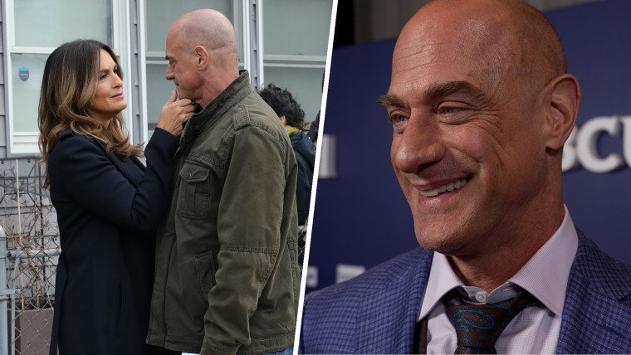

## [Chris Meloni reveals story behind ‘Law & Order’ set pics with Mariska Hargitay](https://www.today.com/video/chris-meloni-reveals-story-behind-law-order-set-pics-with-mariska-hargitay-140215365697)

MAY 17, 202203:35

## I saw you responded to one of the fans and mentioned the Greek words for different kinds of love. So I'm curious which one of those words you would use to describe what's in store for Benson and Stabler in the first half of the season before Christmas.

**DG:** I would say they start off with kind of Philia, you know familial love, and that's what they have and have had for all of these years. It's sort of passionate from afar. There's a little Eros (sensual love) mixed in there: That's what the fans are picking up on for sure. And there's the romantic love that is the ideal. And maybe, maybe toward the end of whatever run we can ultimately get out of the show, there'll be some sort of rapprochement there and some slaying of monsters that'll lead to something approaching romantic love.

**MC: MHMM.**

**JM:** I think what you will certainly see in the movie (premiere) is them having a great, great working relationship and falling into that easy partnership, camaraderie and partnership, kind of knowing what the other person is thinking. It's fun to see them in that capacity again.

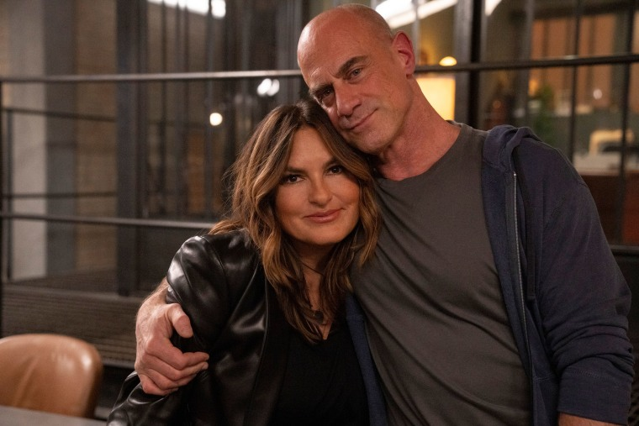"Nobody looked out for me the way he did," Benson once said about Stabler.Virginia Sherwood / NBCU Photo Bank / Getty Images

**DG:** I would say there's a ninth version of Greek love that the Greeks didn't discover because they didn't have this focus on partnerships. But there's like a love between partners and people who work together. ... I think it's what Benson and Stabler have. If there was a ninth kind of love, I'm pretty sure it'd be the love partnership.

## **Was Benson’s conversation with Rafael Barba (**Raúl Esparza) **in the Season 23 finale meant to set up a love triangle of sorts with Benson, Barba and Stabler? Or was Barba’s admission of unconditional love for Benson more platonic?**

**JM:** The intention wasn't to imply a romantic connection between Benson and Barba but a deep love — love as friends. And we certainly hope to see Raúl back some time this season. We have no immediate plans, but he's always welcome to come back into the courtroom.

Raúl Esparza as Rafael Barba in the "SVU" Season 23 finale.Virginia Sherwood / NBC via Getty Images

**DG:** He's just a monstrously talented actor. And just as a fan of the show, every time I saw him on screen, if I had a dial in my hand, like as if I was testing the show, my dial would go way up. He's just —

### *Recommended*



### [TV](https://www.today.com/popculture/tv)[‘Grey’s Anatomy’ mini-reunion! See Sandra Oh’s pic from the Emmys](https://www.today.com/popculture/tv/greys-anatomy-mini-reunion-2022-emmy-awards-rcna47572)



### [TV](https://www.today.com/popculture/tv)[Is Caroline Manzo as Italian as the Olive Garden? Dolores Catania answers](https://www.today.com/popculture/tv/dolores-catania-caroline-manzo-celebrity-beef-rcna47508)

**JM:** Electrifying.

**DG:** He's electrifying, and he's one of the finest lawyers I've seen on the show over the years — other than Carisi. I'm a huge Rollisi shipper.

## Near the end of Season 23, Carisi sort of mentioned possibly proposing to Rollins. So I'm wondering what the road ahead looks like for them in the next season.

**DG:** He's got a drawer in her apartment, which is a pretty big commitment. ... They start out with a very familial, comfortable relationship. We see that it's advanced a little bit. He's very good with the girls. There are a couple of moments in some of these scenes that he is just like a father figure to them. I think it's important to dwell there and not rush things too fast and get to a wedding. My fervent wish for the show is to have some weird kind of Staten Island wedding.

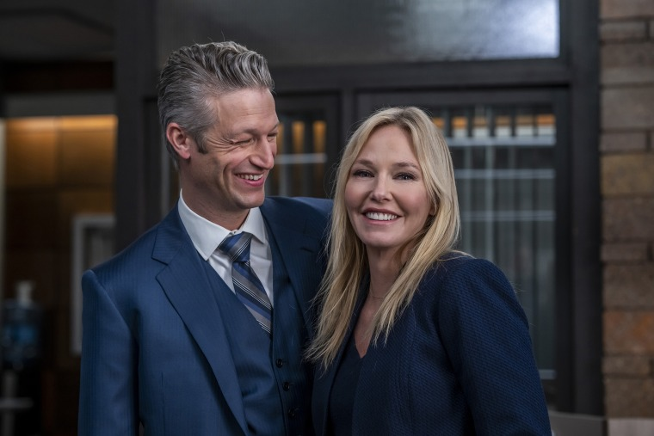Carisi and Rollins are proof "SVU" can do former work partners turned romantic partners.Zach Dilgard / NBC

**JM:** They're moving forward. They'll be facing challenges, but I think ultimately those challenges are going to make their relationship stronger and they're just going to get to know each other better and have a more deep love. Hopefully it ends up at Staten Island.

## Olivia Benson's son, Noah, came out as bisexual in an episode earlier this year. Will this be touched upon again in any episodes in Season 24?

**JM:** It probably will. There's nothing earth-shattering happening immediately, but it's certainly not a storyline that we're just going to abandon and we'll have moments to talk about it.

**DG:** We have some events that we have to sort of play out that come on the heels of the premiere event, and we're spending a lot of real estate on those. That scene represents a young man's search for identity. The thing to play, much like "The Sopranos" played it with A.J., is to show a young man becoming who he's destined to become and like Benson guiding him. It's interesting to note it's no surprise, and viewers of the show will definitely know what I'm talking about, most of the people who have done horrific sexual crimes on the show have been men. What I'm really curious about, someone like Benson in her shoes investigating sex crimes for the past 24 years, what has she learned about raising a healthy man in this world? One that goes on to do good in the world and has a healthy sense of self, regardless of sexuality. I'm interested in how her job informs her role as a parent.

## We recently saw Dann Florek reprise Cragen on 'SVU' and 'Organized Crime.' Are there any other characters from the first 10 or so years of 'SVU' that you think would be fun to bring back for guest appearances?

**DG:** Munch! I would kill for that. I don't think it's going to happen. He seems to be happily wiling away his retirement in France. So I don't think that's going to happen any time soon. But Betty Buckley, for me, it's like in terms of being an elder statesman on the show, it's like we're just having so much fun writing for her and the relationship between her as this patrician, super powerful, heavily connected, kind of slightly cheeky power broker of the city and then to see her in scenes with Benson, who is used to being the 800-pound gorilla wherever she goes. They've been fascinating to write for us, and it's like a really cool color for the show, a cool feminist color for the show too to see these two women sort of trying to horse trade a little bit for things that Benson might need.

Tamara Tunie portrayed medical examiner Melinda Warner (left), Richard Belzer played Detective John Munch (front right) and Dann Florek portrayed Capt. Don Cragen (back right) in the early seasons of "SVU."Walter Thomson / NBCUniversal via Getty Images

**JM:** I always had a soft spot for Tamara Tunie for our M.E. So hopefully we'll find an opportunity for her to come back this season.

**MC:** No one asked me, but I love Marcia Gay Harden. Bring back Dana Lewis.

**JM:** (laughs) She's in prison.

**DG:** I loved her run on the show. I'm in the free Dana Lewis camp.

*This interview has been edited and condensed for clarity.*

*"Law & Order: SVU" returns Sept. 22 at 9 p.m. ET as part of a crossover premiere event with "Law & Order" at a special time, 10 p.m., and "Law & Order: Organized Crime" also at a special time, 8 p.m.*